**Opening a Business in Toronto**

Report

**1. Introduction**

This study is to help people choose the ideal type of business to open in Toronto by providing information about the most common venues located in the Toronto Neighborhoods currently. If you are looking to open a business in Toronto this will help you establish what venues are popular currently and what the population is in most need of.

**2. Data**

For this study we will be using data found from:

*https://en.wikipedia.org/wiki/List_of_postal_codes_of_Canada*:_M: Neighborhoods in Toronto

*http://cocl.us/Geospatial_data:* Location of Toronto Neighborhoods

*https://api.foursquare.com*: to find competitors in the same neighborhood

**3. Methodology**

After cleaning the data we are able to get a look at the locations of the neighborhoods in Toronto and the venues.

Then we sort this data to see which venues are the most common in each specific location.

Lastly, we merge the two tables together to see the location of these venues and map the data. This shows us where in Toronto gets the most business and which venues specifically.

**4. Data Analysis**

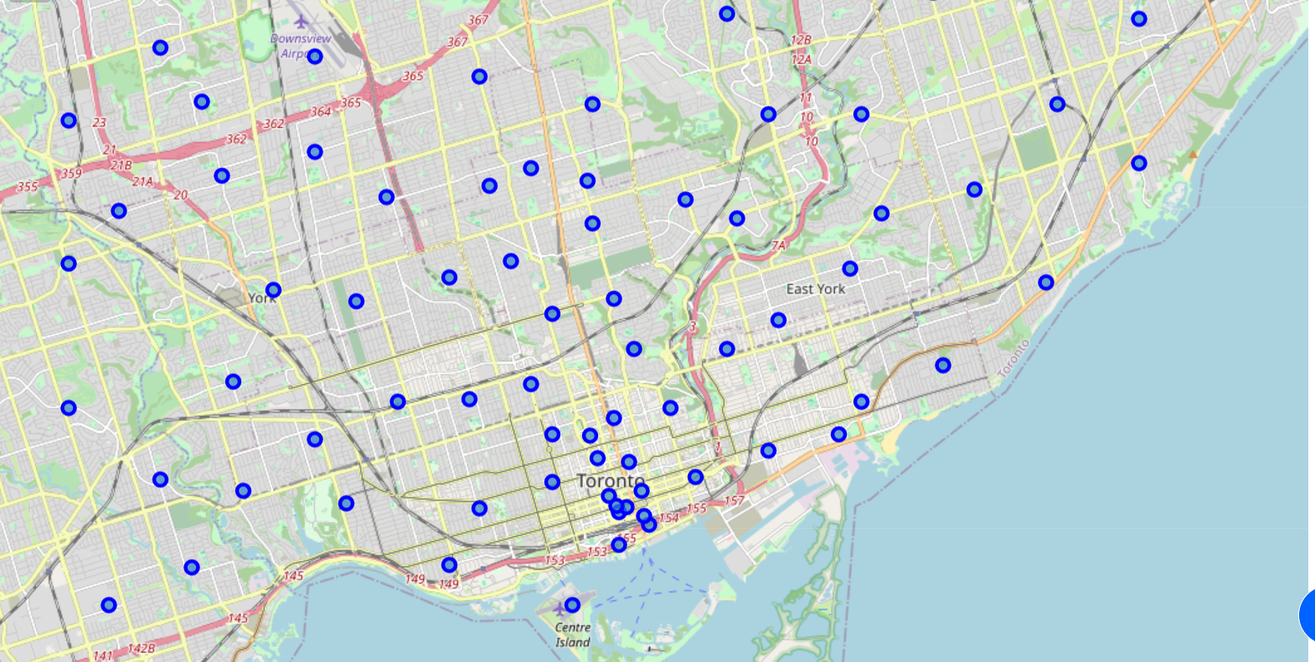

1. **Map of Toronto Neighborhoods**

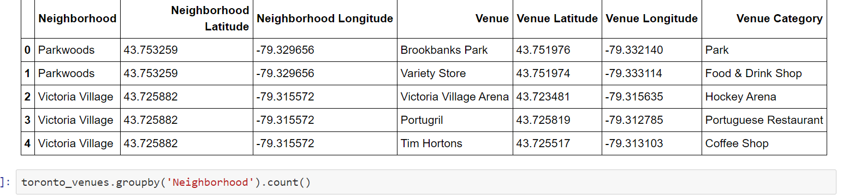

1. **Merged table of toronto neighborhoods and venues using foursquare api**

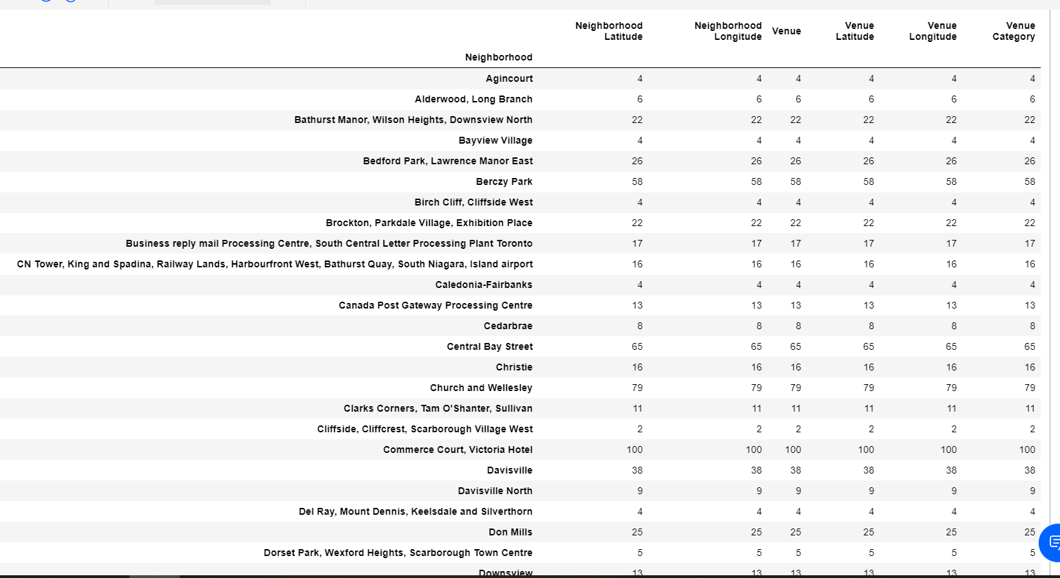

1. **Toronto neighborhoods venue locations**

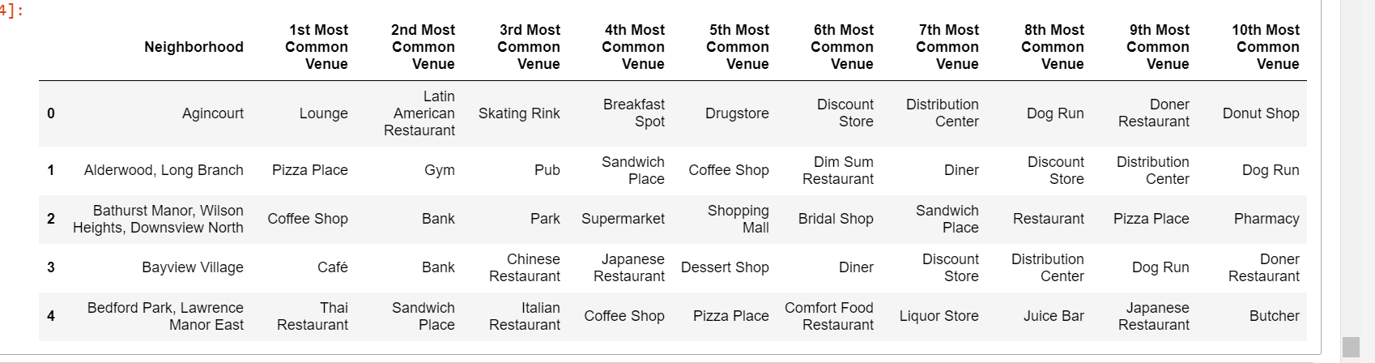

1. **Toronto neighborhoods and most common venues**

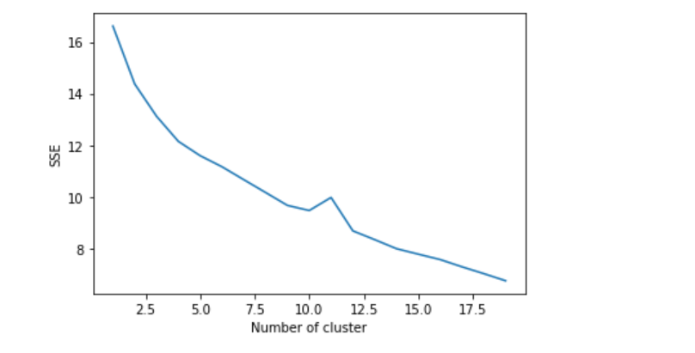

1. **Cluster analysis of venues in Toronto: as you can see as the number of clusters increases the sum of squares (SSE) decreases which shows that as the number of clusters increases the more similar the consumers will be in the market.**

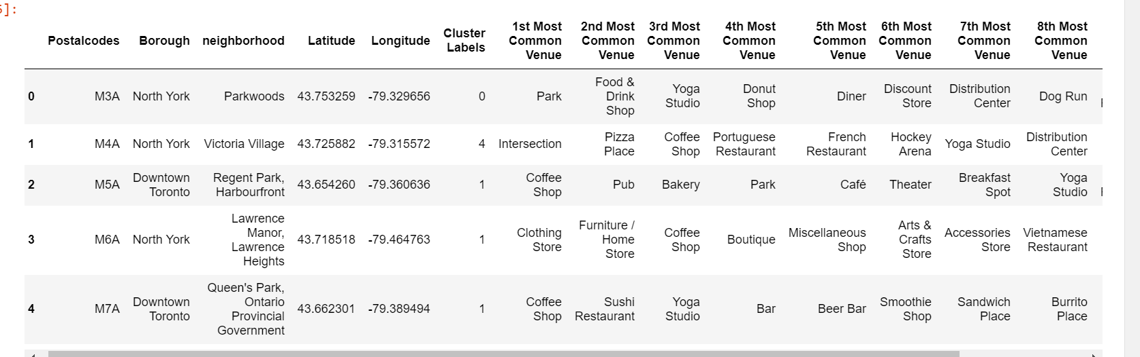

1. **Merged table for location of Toronto neighborhoods and the common venues in the area.**

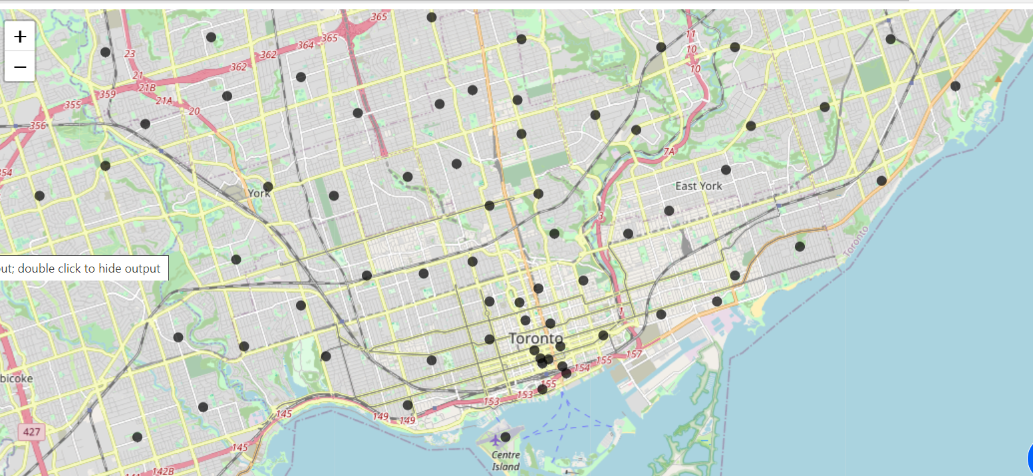

1. **Map of clusters in Toronto neighborhoods of common venues**

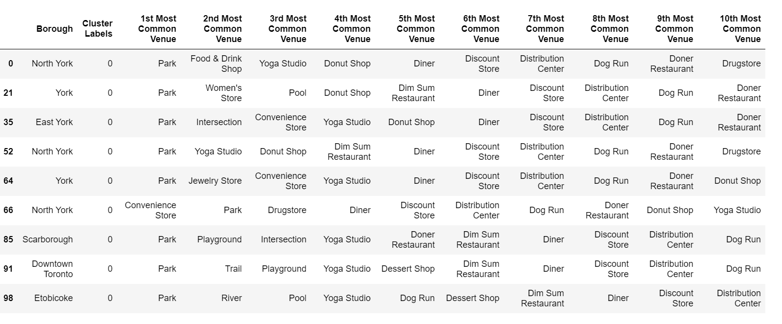

1. **Boroughs with cluster 0 for common venues: which are parks.**

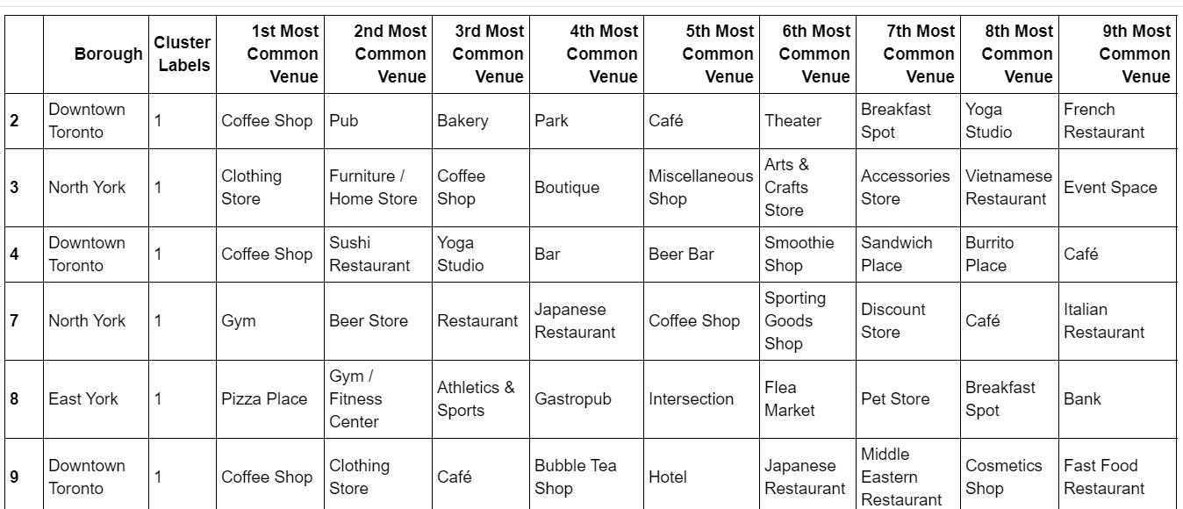

1. **Boroughs with custer 1 for common venues: which are coffee shops**

**5. Results and Discussion**

The analysis shows that after the cluster analysis the most popular businesses opened in Toronto are, parks and coffee shops. The area in Toronto with most business seems to be Union with must clustering. Therefore if a business was to be opened in Toronto it shows that in this particular area where the train is departing people tend to buy coffee and wait at neary parks. A business that can be opened in order to ensure people are occupied during their wait time for the train seems to be the most optimal business idea.

We can also see that every area near Tornto’s most common venue in cluster 1 are parks. People tend to prioritize their time in nature, therefore it seems that a good business idea may be opening up a park. It seems to get a lot of business or activities people can do in parks and it is a common venue for most Toronto neighborhoods.

Restaurants are another common venue as we can see in the table. Cafes especially are the most common food store, people in Toronto work early hours and therefore breakfast is a meal that is skipped regularly. Opening up a restaurant in Union station for breakfast food is a business that is highly likely to be successful.

**7. Conclusion**

In conclusion, this study was obtained to highlight areas in Toronto to open a business and the type of business that would be most successful to the population of Toronto. As we can see after cluster analysis is that the area in Toronto that has the most common venues are Downtown Toronto, near Union. This is due to the large population of people who are commuting to Toronto, the most business is seen in this area with venues like coffee shops, parks and cafes that seem to be the most desired at the times people arrive or depart from the train station.